Relative Population Densities of Asian Carp in the Tennessee River and Cumberland Rivers, Tributaries of the Ohio River

2019 Technical Report

Geographic Location: Ohio River Basin; Tennessee and Cumberland rivers

Lead Agency: Tennessee Wildlife Resources Agency (TWRA; Cole Harty, cole.r.harty@tn.gov).

Participating Agencies: TWRA, Kentucky Department of Fish and Wildlife Resources (KDFWR), Mississippi Department of Wildlife, Fisheries, and Parks (MDWFP), Alabama Department of Conservation and Natural Resources, Tennessee Technological University (TTU), U.S. Geological Survey (USGS), U.S. Fish and Wildlife Service (USFWS).

Introduction:
In 2004, the USFWS and the Aquatic Nuisance Species (ANS) Task Force formed the Asian Carp Working Group in response to a request for the development of a national management and control plan for all species of Asian carp. The “Management and Control Plan for Bighead, Black, Grass, and Silver Carps in the United States” was published in October, 2007, with the objective of “providing strategies and recommendations to address various aspects of prevention, control, and management” of the four Asian carp species (Conover et al. 2007). The goal of the plan is the complete extirpation of invasive Asian carp species from waters in the U.S. Since drafting the management plan, intensive research efforts have been conducted to expand knowledge of Asian carp in the U.S., particularly to assess population dynamics (e.g., growth, recruitment, and abundance), determine the potential for a commercial market, assess effective capture methods, and determine habitat use and diets. States in which Asian carp are well established, such as Arkansas, Missouri, and Illinois, have already conducted studies assessing population characteristics and local distributions and movement. States where Asian carp have more recently been found (i.e., Kentucky, Tennessee, South Dakota) are beginning to conduct research on the “leading edge” of distribution to determine local population characteristics, ecosystem effects, and potential management plans and control efforts.

Within the national management plan, sub-basin strategies for combating the spread of Asian carp help focus efforts within specific regions of the U.S. Since their introduction, Asian carp have spread into many of the major tributaries of the Mississippi River, including the Ohio River (Conover et al. 2007). The Ohio River basin is comprised of the Ohio River watershed that spans 15 states, including Illinois, Indiana, Ohio, New York, Pennsylvania, Kentucky, West Virginia, Virginia, Maryland, Tennessee, North Carolina, South Carolina, Alabama, Mississippi, and Georgia. The Ohio River Basin Asian Carp Control Strategy Framework reflects the goals of the national plan. The framework aims to prevent further spread of Asian carp throughout the basin, assess the specific ecological impacts of Asian carp invasion on the Ohio River and its tributaries, and develop control strategies for the four Asian carp species.

Research and monitoring on bigheaded carp (i.e., Silver carp Hypophthalmichthyes molitrix and Bighead carp H. nobilis) in the Tennessee and Cumberland rivers was initiated fairly recently, and both are tributaries of the Ohio River. Bighead Carp were first reported in Tennessee in 1994 and Silver Carp in 1989 (Kolar et al. 2007). In April 2014, the Kentucky Department of Fish and Wildlife Resources (KDFWR) reported two large Asian carp die-offs below Kentucky and Barkley dams. Species included Bighead, Silver, and Grass Carp Ctenopharyngodon idella. Upon investigation, the die-offs were attributed to gas bubble disease, a condition caused by the exposure of fish to water supersaturated with gasses (KDFWR 2014b). Several carp specific fish kills also occurred in the spring and fall of 2017, with the cause attributed to the commonly found bacteria Aeromonas hydrophila (TWRA 2017). To date, Bigheaded carp have been reported as far as Chickamauga Reservoir on the Tennessee River (TWRA, personal communication). Silver Carp have also been observed as far as Old Hickory Reservoir on the Cumberland River (USFWS 2016) and no Bigheaded carp eDNA was detected at Cordell Hull in fall 2019 (TTU, personal observation). A study conducted by Tennessee Tech University confirmed the presence of bigheaded carp in Kentucky Reservoir and Barkley Reservoir, and characteristics of both populations (including high growth rates, robustness, and skewed sex ratios) were indicative of the early stages of invasion and colonization (Ridgway 2016). However, the study was based on opportunistic sampling to gather initial population data without formal sampling design. As both species continue to spread throughout the Tennessee and Cumberland rivers, more systematically collected data is needed to determine their distribution and abundance.

Objective:
- Conduct targeted sampling for the purpose of surveillance, early detection, distribution, and relative population characteristics of Asian carp in the Tennessee and Cumberland rivers.

Within Objective 1 there are three sub-components that are addressed below in methods, and results.

1-a. Use catch data to assess spatial variation in relative densities of bigheaded carp in lower impoundments of the Tennessee and Cumberland rivers.

1-b. Assess population characteristics (i.e., size structure, condition, and sex characteristics) of bigheaded carp within selected reservoirs of the Tennessee and Cumberland rivers.

1-c. Assess the efficacy of standardized sampling methods for capturing bigheaded carp in large impoundments.

Methods:
Reservoirs on the Tennessee and Cumberland rivers were systematically sampled to assess spatial variation in relative densities of bigheaded carp across their longitudinal gradients. Sampling reaches were chosen at approximately equally spaced intervals throughout each reservoir and based on sampling gear constraints (e.g., depth, barge traffic) and the advice of biologists familiar with the study systems (e.g., TWRA and USGS). One reach was sampled in the lacustrine (downstream), transition, and riverine (upstream) zones of Kentucky Reservoir and Barkley Reservoir. In Kentucky Reservoir, the downstream reach was located near Kentucky Dam, transition reach near Big Sandy embayment, and upstream reach near the Duck River (Figure 1). In Barkley Reservoir, the downstream reach was located near Barkley Dam, transition reach near the Little River embayment, and upstream reach near the Saline Creek embayment (Figure 1). One reach was sampled in the upstream and downstream zones of Pickwick Reservoir and Cheatham Reservoir. In Pickwick Reservoir, the downstream reach was located near Pickwick Dam and upstream reach near Bear Creek embayment (Figure 1). In Cheatham Reservoir, the downstream reach was located near Cheatham Dam and upstream reach near Sycamore Creek (Figure 1). During each sampling event, water temperature and global positioning system (GPS) coordinates of sample locations were recorded.

The sampling design and procedure was similar to protocols used by commercial fishers in Kentucky and Tennessee and the methods described by Welker and Drobish (2010) and Ridgway (2016). Experimental monofilament gill nets were used, and each net consisted of two 45.7 m panels of either 76 and 89 mm square meshes (Type-I net) or 101 and 108 mm square meshes (Type-II net). All nets were 3.7 m in height, hobbled down to 2.4 m, and had a lead core bottom line and an 8 mm diameter foam core top line. Nets were set as floating sets and in gangs, with one of each net type deployed at a sampling site. Four sites were fished per sampling reach in all reservoirs using short, 2-hour gill net sets in summer 2017. Since 2017, three sites were fished per sampling reach in all reservoirs using overnight gill net sets due to increased catches and no evidence of bycatch mortality, with specific concern for American paddlefish Polyodon spathula (Bettoli and Scholten 2006). Net sets were placed in areas of low water velocity at depth ranges of 1.8-6 m. Catch-per-unit effort (CPUE) was calculated as mean catch in a gang per duration of net set. In 2019, collaborators received increased funding to commence similar, standardized sampling using gill nets. In 2020, efforts to share data and ensure comparative methods will be discussed and identified.

In 2019, the project underwent a switch from standard boat electrofishing to using an electrified dozier trawl (see Hammen et al. 2019) for summer sampling. The purpose of the switch was based on the effectiveness of using an active gear at other invasion localities with capabilities of detecting smaller fish than could be detected with standardized gill net sampling mesh sizes. In July 2019, the electrified dozer trawl was deployed for sampling at Kentucky Reservoir and Barkley Reservoir. The electrified dozer trawl captured Silver carp, but revealed no collections of juvenile fish under 400 mm. The electrified dozier trawl will continue to be used in 2020 and cooperative efforts with federal and state partners for sampling efficiency will be ongoing in 2020.

Bighead and Silver Carp were identified based on characteristics described by Kolar et al. (2007); measured (total length (TL), mm), weighed (g), sexed, and the left gonad was weighed (g) for females to estimate gonadosomatic index (i.e., gonad weight divided by body weight; GSI). Lapilli otoliths were also collected from a subsample of total fish catch for age estimation. Otolith processing procedures are being continually discussed as there is still no set agreement on whether this is the proper aging structure or how methods and agreement vary. Bycatch in gill nets was enumerated by reservoir, species, and season and mortalities were recorded and reported to the states of Tennessee and Kentucky following their sampling permit requirements.

In 2019, cast netting was eliminated as a sampling method because it is only selective for YOY fish and the electrified dozer trawl has the ability to collect those fish if present.

Results and Discussion:

Objective 1-a)
Standardized, systematic gill nets captured 1,213 Asian carp in 2019 across the four study reservoirs within the Tennessee and Cumberland rivers. With standardized nets, catch per unit effort continues to peak in the May to June period. However, 2019 early spring sampling was disrupted by the U.S. Federal government shutdown and record floods within the basin that restricted sampling capabilities. In 2019, we continued to see variability in catches among sites and seasons. Results from our standardized, systematic sampling illustrate seasonality of catches with implications for standardized, cross-state sampling.

Importantly, standardized systematic sampling does not target areas of high density that fisheries-dependent data would likely reflect. Systematic sampling does inform relative densities across reservoirs across years. 2019 data show that catch per gill net are twice as high at Barkley Reservoir than Kentucky Reservoir, but catches per effort at Cheatham Reservoir and Pickwick Reservoir are similar. Indeed, the design is purposely intended to sample where fish may not have been present last year, but if populations are expanding may be captured in following years and continued years of data have not indicated a change in the pattern since systematic sampling began. The variability of data within a reservoir illustrates the importance of a spatially stratified design for monitoring. Targeted commercial fisheries could certainly capture more fish as a removal method than a standardized monitoring survey, yet commercial fisheries are unprofitable in some areas and highlight the need for spatially stratified agency monitoring to inform population expansion and leading edge.

Objective 1-b)
Gill net catches from spring 2019 are presented in Table 1 for each reservoir. No Bigheaded carp less than 479 mm were captured in any gears used in 2019. Age estimation is ongoing and methodologies are being refined. Disagreement in age estimates between readers using lapilli otoliths precludes the ability to incorporate age structure data in this report. Discussion on protocols and techniques with partner agencies is underway.

Gonadosomatic Index (GSI) provides an indicator of how much energy is invested into egg production and an index of spawning time. GSI values were estimated for 334 Silver Carp collected in spring with overnight gill net sets. GSI values were 5.5% at Barkley Reservoir, 15.1% at Cheatham Reservoir, 1.5% at Kentucky Reservoir, and 5.9% at Pickwick Reservoir. Only 5 female Bighead Carp were collected in spring overnight gill net sets across all four reservoirs, and thus, GSI values are not presented. It is important to note that Cheatham Reservoir was sampled in March 2019, but due to record flooding the sub-basin, spring gill net sampling at the other reservoirs occurred in late May 2019 after water levels and flows receded. Thus, “spring” GSI levels are not similar through time. GSI is continued to be collected through the summer but using a different gear that could potentially have differing selectivity or after some fish released or reabsorbed eggs.

Objective 1-c)
Total bycatch included 21 fish species. Buffalo Ictiobus spp. and Common Carp Cyprinus carpio comprised 48% of all bycatch. Skipjack Herring Alosa chysochloris had high mortality and were less than 4% of total bycatch. Grass Carp, another species of Asian carp, were 9.3% of all bycatch.

Following experiences working with USFWS, an electrofishing boat was outfitted to replicate the dozier trawl and replaced standard electrofishing and cast netting in 2019. Forty-eight electrified dozier trawl transects were sampled during summer 2019 at Barkley Reservoir and Kentucky Reservoir. Transects were 5 minutes in duration. Catches highly varied with many zero catches, but multiple trawls that caught more than ten Silver Carp and a few trawls that caught approximately 30 Silver Carp. The dozier trawl will be used again in summer 2020.

Extreme spring rains in spring 2019 and the U.S. federal government shutdown in December to late January 2019 greatly impacted spring sampling capability. Sampling sites that provided conditions for sampling were limited. Starting in 2019, KDFWR and TWRA initiated a standardized monitoring program that will allow comparable data across jurisdictions using similar gear and sampling timing. The current project described above has contributed to the planning and will supplement their efforts following similar protocols.

References:
Bettoli, P. W. and G. D. Scholten. 2006. Bycatch rates and initial mortality of paddlefish in a commercial gillnet fishery. Fisheries Research 77: 343-347.
Bouska, W. W., D. C. Glover, K. L. Bouska and J. E. Garvey. 2017. A refined electrofishing technique for collecting silver carp: implications for management. North American Journal of Fisheries Management 37: 101-107
Collins, S. F., S. E. Butler, M. J. Diana and D. H. Wahl. 2015. Evaluation of gear efficiency and Asian carp detectability. Asian Carp Monitoring and Response Plan Interim Summary Reports 194-200. Illinois Natural History Survey, Champaign-Urbana.
Conover, G., R. Simmonds and M. Whalen. 2007. Management and control plan for bighead, black, grass, and silver carps in the United States. Asian Carp Working Group, Aquatic Nuisance Species Task Force, Washington, D. C.
Hammen, J.J., E. Pherigo, W. Doyle, F. Finley, K. Drews., and J. Goeckler. 2019. A coparison between conventional boat electrofishing and the electrified dozer trawl for capturing Silver Carp in tributaries of the Missouri River, Missouri. North American Journal of Fisheries Management https://doi.org/10.1002/nafm.10297

Hayer, C., J. J. Breeggemann, R. A. Klumb, B. D. S. Graeb and K. N. Bertrand. 2014. Population characteristics of bighead and silver carp on the northwestern front of their North American invasion. Aquatic Invasions 9: 289-303.
KDFWR (Kentucky Department of Fish and Wildlife Resources). 2014a. Asian Carp Information. Accessed online at https://fw.ky.gov/Fish/Pages/Asian-Carp-Information.aspx (August 2017).
KDFWR (Kentucky Department of Fish and Wildlife Resources). 2014b Kentucky and Barkley Lake Asian carp fish kill. Accessed online at http://fw.ky.gov/fish/pages/ky-barkley-fishkill.aspx (August 2017).
Kolar, C., D. Chapman, W. Courtenay, C. Housel, J. Williams and D. Jennings. 2007. Asian carps of the genus Hypophthalmichthys (Pisces, Cyprinidae) – A Biological Synopsis and Environmental Risk Assessment. American Fisheries Society Special Publication 33, Bethesda.
Ridgway, J. L. 2016. Sampling and population characteristics of bighead carp and silver carp in the Tennessee and Cumberland River systems. Master’s Thesis. Tennessee Technological University, Cookeville, Tennessee.
TWRA (Tennessee Wildlife Resources Agency). 2017. Asian Carp in Tennessee. Accessed online at https://www.tn.gov/twra/wildlife/fish/asian-carp.html (May 2018).
USFWS (U.S. Fish and Wildlife Service). 2016. Annual summary of activities and expenditures to manage the threat of Asian Carp in the Upper Mississippi and Ohio river basins. Available: https://www.asiancarp.us/Documents/WRRDA2016.pdf (October 2018).
Welker, T. L. and M. R. Drobish. (editors), 2010. Missouri River standard operating procedures for fish sampling and data collection, Volume 1.5. U. S. Army Corps of Engineers, Omaha District, Yankton, SD.

Table 1. Silver Carp captures by length group and reservoir from spring 2019 overnight gill nets. Mesh sizes were the same across sampling site.
Length group (100mm) | Barkley Reservoir | Cheatham Reservoir | Kentucky Reservoir | Pickwick Reservoir
400 | 0 | 0 | 1 | 0
500 | 28 | 0 | 67 | 0
600 | 190 | 5 | 52 | 1
700 | 32 | 17 | 0 | 72
800 | 66 | 14 | 4 | 79
900 | 11 | 7 | 2 | 0

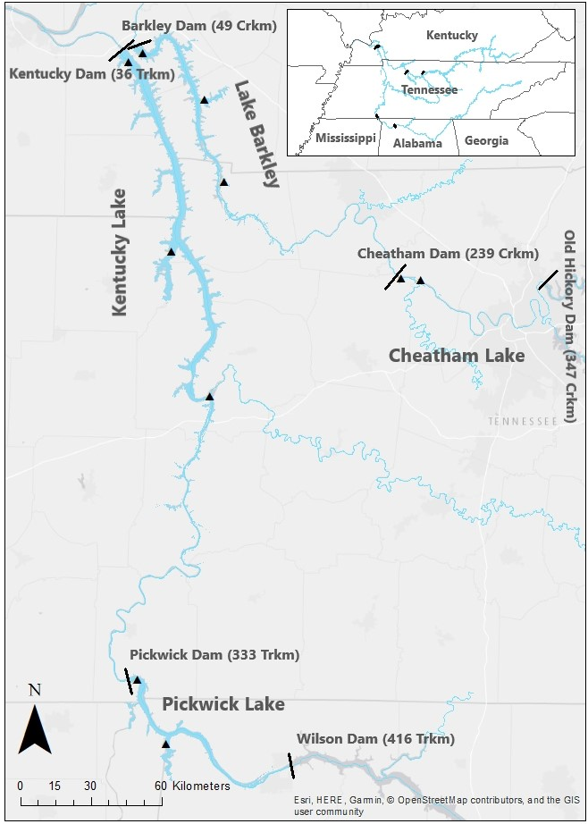
Duck River
Figure 1. Locations on Tennessee and Cumberland river reservoirs where bigheaded carp were sampled using standardized methods from 2017 through 2019.

